Untitled
2025-06-13
#install.packages("caTools")
#install.packages("car")
#install.packages("quantmod")
#install.packages("MASS")
#install.packages("corrplot")
#install.packages("leaps")
#install.packages("Metrics")
#install.packages("tidyr")
#install.packages("dplyr")
library(caTools)
## Warning: package 'caTools' was built under R version 4.4.3
library(car)
## Warning: package 'car' was built under R version 4.4.3
## Loading required package: carData
## Warning: package 'carData' was built under R version 4.4.3
library(quantmod)
## Warning: package 'quantmod' was built under R version 4.4.3
## Loading required package: xts
## Warning: package 'xts' was built under R version 4.4.3
## Loading required package: zoo
## Warning: package 'zoo' was built under R version 4.4.3
##
## Attaching package: 'zoo'
## The following objects are masked from 'package:base':
##
## as.Date, as.Date.numeric
## Loading required package: TTR
## Warning: package 'TTR' was built under R version 4.4.3
## Registered S3 method overwritten by 'quantmod':
## method from
## as.zoo.data.frame zoo
library(MASS)
## Warning: package 'MASS' was built under R version 4.4.3
library(corrplot)
## Warning: package 'corrplot' was built under R version 4.4.3
## corrplot 0.95 loaded
library(Metrics)
## Warning: package 'Metrics' was built under R version 4.4.3
library(tidyr)
## Warning: package 'tidyr' was built under R version 4.4.3
library(dplyr)
## Warning: package 'dplyr' was built under R version 4.4.3
##
## ######################### Warning from 'xts' package ##########################
## # #
## # The dplyr lag() function breaks how base R's lag() function is supposed to #
## # work, which breaks lag(my_xts). Calls to lag(my_xts) that you type or #
## # source() into this session won't work correctly. #
## # #
## # Use stats::lag() to make sure you're not using dplyr::lag(), or you can add #
## # conflictRules('dplyr', exclude = 'lag') to your .Rprofile to stop #
## # dplyr from breaking base R's lag() function. #
## # #
## # Code in packages is not affected. It's protected by R's namespace mechanism #
## # Set `options(xts.warn_dplyr_breaks_lag = FALSE)` to suppress this warning. #
## # #
## ###############################################################################
##
## Attaching package: 'dplyr'
## The following object is masked from 'package:MASS':
##
## select
## The following objects are masked from 'package:xts':
##
## first, last
## The following object is masked from 'package:car':
##
## recode
## The following objects are masked from 'package:stats':
##
## filter, lag
## The following objects are masked from 'package:base':
##
## intersect, setdiff, setequal, union
library(leaps)
## Warning: package 'leaps' was built under R version 4.4.3
worldometer_data <- read.csv("C:\\Users\\Acer\\Downloads\\worldometer_data.csv")
View(worldometer_data)
names(worldometer_data)
## [1] "Country.Region" "Continent" "Population" "TotalCases"
## [5] "NewCases" "TotalDeaths" "NewDeaths" "TotalRecovered"
## [9] "NewRecovered" "ActiveCases" "Serious.Critical" "Tot.Cases.1M.pop"
## [13] "Deaths.1M.pop" "TotalTests" "Tests.1M.pop" "WHO.Region"
str(worldometer_data)
## 'data.frame': 209 obs. of 16 variables:
## $ Country.Region : chr "USA" "Brazil" "India" "Russia" ...
## $ Continent : chr "North America" "South America" "Asia" "Europe" ...
## $ Population : int 331198130 212710692 1381344997 145940924 59381566 129066160 33016319 19132514 50936262 46756648 ...
## $ TotalCases : int 5032179 2917562 2025409 871894 538184 462690 455409 366671 357710 354530 ...
## $ NewCases : int NA NA NA NA NA 6590 NA NA NA NA ...
## $ TotalDeaths : int 162804 98644 41638 14606 9604 50517 20424 9889 11939 28500 ...
## $ NewDeaths : int NA NA NA NA NA 819 NA NA NA NA ...
## $ TotalRecovered : int 2576668 2047660 1377384 676357 387316 308848 310337 340168 192355 NA ...
## $ NewRecovered : int NA NA NA NA NA 4140 NA NA NA NA ...
## $ ActiveCases : int 2292707 771258 606387 180931 141264 103325 124648 16614 153416 NA ...
## $ Serious.Critical: int 18296 8318 8944 2300 539 3987 1426 1358 1493 617 ...
## $ Tot.Cases.1M.pop: int 15194 13716 1466 5974 9063 3585 13793 19165 7023 7582 ...
## $ Deaths.1M.pop : num 492 464 30 100 162 391 619 517 234 610 ...
## $ TotalTests : int 63139605 13206188 22149351 29716907 3149807 1056915 2493429 1760615 1801835 7064329 ...
## $ Tests.1M.pop : int 190640 62085 16035 203623 53044 8189 75521 92022 35374 151087 ...
## $ WHO.Region : chr "Americas" "Americas" "South-EastAsia" "Europe" ...

We dicided to remove NewCases, NewDeaths, NewRecovered because of they have lot of missing values and there are variables with totals (TotalCases, TotalDeaths ,TotalRecovered),

Also we remove ActiveCases, Series.Critical because of lot of missing values we remove those variables
corona <- worldometer_data[,-c(5,7,9,10,11)]
head(corona)
## Country.Region Continent Population TotalCases TotalDeaths TotalRecovered
## 1 USA North America 331198130 5032179 162804 2576668
## 2 Brazil South America 212710692 2917562 98644 2047660
## 3 India Asia 1381344997 2025409 41638 1377384
## 4 Russia Europe 145940924 871894 14606 676357
## 5 South Africa Africa 59381566 538184 9604 387316
## 6 Mexico North America 129066160 462690 50517 308848
## Tot.Cases.1M.pop Deaths.1M.pop TotalTests Tests.1M.pop WHO.Region
## 1 15194 492 63139605 190640 Americas
## 2 13716 464 13206188 62085 Americas
## 3 1466 30 22149351 16035 South-EastAsia
## 4 5974 100 29716907 203623 Europe
## 5 9063 162 3149807 53044 Africa
## 6 3585 391 1056915 8189 Americas
sum(is.na(corona))
## [1] 85
df <- na.omit(corona)
pairs(df[,-c(1,2,11)])
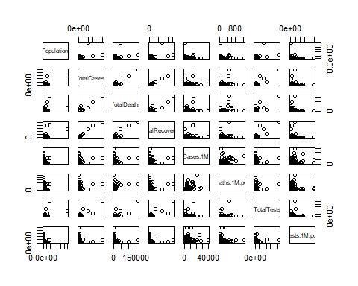
corona$Continent
## [1] "North America" "South America" "Asia"
## [4] "Europe" "Africa" "North America"
## [7] "South America" "South America" "South America"
## [10] "Europe" "Asia" "Europe"
## [13] "Asia" "Asia" "Asia"
## [16] "Europe" "Asia" "South America"
## [19] "Europe" "Europe" "Asia"
## [22] "Asia" "Asia" "North America"
## [25] "Asia" "Asia" "Africa"
## [28] "South America" "South America" "Europe"
## [31] "Asia" "Asia" "Europe"
## [34] "North America" "North America" "Europe"
## [37] "Asia" "Europe" "Asia"
## [40] "Europe" "Europe" "Asia"
## [43] "North America" "Europe" "Europe"
## [46] "Africa" "North America" "Asia"
## [49] "Asia" "Asia" "Africa"
## [52] "Asia" "Asia" "Europe"
## [55] "Africa" "Asia" "Africa"
## [58] "Asia" "Europe" "Europe"
## [61] "Europe" "Africa" "South America"
## [64] "Asia" "Europe" "North America"
## [67] "Africa" "Australia/Oceania" "North America"
## [70] "Europe" "Africa" "Africa"
## [73] "Asia" "Europe" "Asia"
## [76] "Europe" "Europe" "Africa"
## [79] "Africa" "Europe" "Africa"
## [82] "Europe" "Africa" "Asia"
## [85] "South America" "Africa" "Asia"
## [88] "Africa" "North America" "Europe"
## [91] "Africa" "Europe" "Africa"
## [94] "South America" "Europe" "Asia"
## [97] "Europe" "Africa" "Europe"
## [100] "Africa" "Africa" "Asia"
## [103] "Africa" "Europe" "Africa"
## [106] "Africa" "North America" "Asia"
## [109] "Africa" "Europe" "Asia"
## [112] "Africa" "Africa" "Africa"
## [115] "Asia" "North America" "Africa"
## [118] "Africa" "Africa" "Europe"
## [121] "Africa" "Europe" "Europe"
## [124] "Europe" "Africa" "Africa"
## [127] "South America" "Africa" "Africa"
## [130] "Europe" "Africa" "Asia"
## [133] "Africa" "Australia/Oceania" "Africa"
## [136] "South America" "Europe" "Asia"
## [139] "Africa" "Africa" "Asia"
## [142] "Asia" "Africa" "Africa"
## [145] "Africa" "Asia" "North America"
## [148] "Europe" "Europe" "Africa"
## [151] "Africa" "Africa" "Africa"
## [154] "North America" "Asia" "Africa"
## [157] "" "Europe" "Africa"
## [160] "Europe" "South America" "Africa"
## [163] "Asia" "Africa" "Africa"
## [166] "Asia" "Africa" "Europe"
## [169] "Asia" "Africa" "North America"
## [172] "North America" "Europe" "North America"
## [175] "Asia" "North America" "North America"
## [178] "Europe" "Australia/Oceania" "North America"
## [181] "North America" "Asia" "North America"
## [184] "North America" "Africa" "Europe"
## [187] "Asia" "North America" "Europe"
## [190] "North America" "Australia/Oceania" "North America"
## [193] "North America" "Asia" "North America"
## [196] "Australia/Oceania" "North America" "Asia"
## [199] "North America" "Australia/Oceania" "Asia"
## [202] "North America" "North America" "North America"
## [205] "North America" "North America" "South America"
## [208] "Europe" "Africa"
boxplot(corona$TotalDeaths ~ corona$Continent)
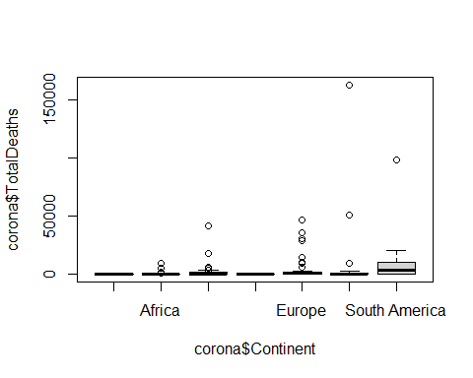
boxplot(corona$TotalDeaths~corona$WHO.Region)
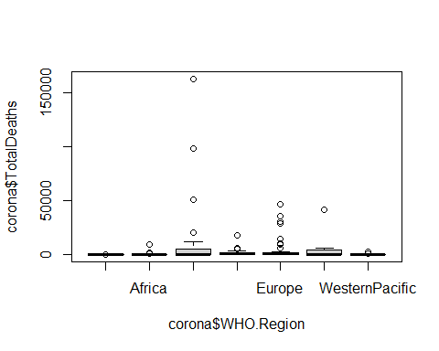

using best subset selection fit regression model to predict total death rate.
model <- regsubsets(TotalDeaths ~ ., data = corona[,-1])
summary(model)
## Subset selection object
## Call: regsubsets.formula(TotalDeaths ~ ., data = corona[, -1])
## 18 Variables (and intercept)
## Forced in Forced out
## ContinentAsia FALSE FALSE
## ContinentAustralia/Oceania FALSE FALSE
## ContinentEurope FALSE FALSE
## ContinentNorth America FALSE FALSE
## ContinentSouth America FALSE FALSE
## Population FALSE FALSE
## TotalCases FALSE FALSE
## TotalRecovered FALSE FALSE
## Tot.Cases.1M.pop FALSE FALSE
## Deaths.1M.pop FALSE FALSE
## TotalTests FALSE FALSE
## Tests.1M.pop FALSE FALSE
## WHO.RegionAfrica FALSE FALSE
## WHO.RegionAmericas FALSE FALSE
## WHO.RegionEasternMediterranean FALSE FALSE
## WHO.RegionEurope FALSE FALSE
## WHO.RegionSouth-EastAsia FALSE FALSE
## WHO.RegionWesternPacific FALSE FALSE
## 1 subsets of each size up to 8
## Selection Algorithm: exhaustive
## ContinentAsia ContinentAustralia/Oceania ContinentEurope
## 1 ( 1 ) " " " " " "
## 2 ( 1 ) " " " " " "
## 3 ( 1 ) " " " " " "
## 4 ( 1 ) " " " " " "
## 5 ( 1 ) " " " " " "
## 6 ( 1 ) " " " " " "
## 7 ( 1 ) " " " " " "
## 8 ( 1 ) " " " " " "
## ContinentNorth America ContinentSouth America Population TotalCases
## 1 ( 1 ) " " " " " " "*"
## 2 ( 1 ) " " " " " " "*"
## 3 ( 1 ) " " " " "*" "*"
## 4 ( 1 ) " " " " "*" "*"
## 5 ( 1 ) " " " " "*" "*"
## 6 ( 1 ) " " " " "*" "*"
## 7 ( 1 ) " " "*" "*" "*"
## 8 ( 1 ) " " "*" "*" "*"
## TotalRecovered Tot.Cases.1M.pop Deaths.1M.pop TotalTests Tests.1M.pop
## 1 ( 1 ) " " " " " " " " " "
## 2 ( 1 ) " " " " "*" " " " "
## 3 ( 1 ) " " " " "*" " " " "
## 4 ( 1 ) " " "*" "*" " " " "
## 5 ( 1 ) " " "*" "*" "*" " "
## 6 ( 1 ) " " "*" "*" "*" " "
## 7 ( 1 ) " " "*" "*" "*" " "
## 8 ( 1 ) " " "*" "*" "*" " "
## WHO.RegionAfrica WHO.RegionAmericas WHO.RegionEasternMediterranean
## 1 ( 1 ) " " " " " "
## 2 ( 1 ) " " " " " "
## 3 ( 1 ) " " " " " "
## 4 ( 1 ) " " " " " "
## 5 ( 1 ) " " " " " "
## 6 ( 1 ) " " " " "*"
## 7 ( 1 ) " " "*" " "
## 8 ( 1 ) " " "*" "*"
## WHO.RegionEurope WHO.RegionSouth-EastAsia WHO.RegionWesternPacific
## 1 ( 1 ) " " " " " "
## 2 ( 1 ) " " " " " "
## 3 ( 1 ) " " " " " "
## 4 ( 1 ) " " " " " "
## 5 ( 1 ) " " " " " "
## 6 ( 1 ) " " " " " "
## 7 ( 1 ) " " " " " "
## 8 ( 1 ) " " " " " "
model <- regsubsets(TotalDeaths ~ ., data = corona[,-1], nvmax = 18)
model.summary <- summary(model)
model.summary
## Subset selection object
## Call: regsubsets.formula(TotalDeaths ~ ., data = corona[, -1], nvmax = 18)
## 18 Variables (and intercept)
## Forced in Forced out
## ContinentAsia FALSE FALSE
## ContinentAustralia/Oceania FALSE FALSE
## ContinentEurope FALSE FALSE
## ContinentNorth America FALSE FALSE
## ContinentSouth America FALSE FALSE
## Population FALSE FALSE
## TotalCases FALSE FALSE
## TotalRecovered FALSE FALSE
## Tot.Cases.1M.pop FALSE FALSE
## Deaths.1M.pop FALSE FALSE
## TotalTests FALSE FALSE
## Tests.1M.pop FALSE FALSE
## WHO.RegionAfrica FALSE FALSE
## WHO.RegionAmericas FALSE FALSE
## WHO.RegionEasternMediterranean FALSE FALSE
## WHO.RegionEurope FALSE FALSE
## WHO.RegionSouth-EastAsia FALSE FALSE
## WHO.RegionWesternPacific FALSE FALSE
## 1 subsets of each size up to 18
## Selection Algorithm: exhaustive
## ContinentAsia ContinentAustralia/Oceania ContinentEurope
## 1 ( 1 ) " " " " " "
## 2 ( 1 ) " " " " " "
## 3 ( 1 ) " " " " " "
## 4 ( 1 ) " " " " " "
## 5 ( 1 ) " " " " " "
## 6 ( 1 ) " " " " " "
## 7 ( 1 ) " " " " " "
## 8 ( 1 ) " " " " " "
## 9 ( 1 ) " " " " " "
## 10 ( 1 ) " " " " " "
## 11 ( 1 ) " " " " " "
## 12 ( 1 ) " " " " " "
## 13 ( 1 ) " " " " " "
## 14 ( 1 ) " " " " " "
## 15 ( 1 ) " " "*" " "
## 16 ( 1 ) " " "*" "*"
## 17 ( 1 ) "*" "*" "*"
## 18 ( 1 ) "*" "*" "*"
## ContinentNorth America ContinentSouth America Population TotalCases
## 1 ( 1 ) " " " " " " "*"
## 2 ( 1 ) " " " " " " "*"
## 3 ( 1 ) " " " " "*" "*"
## 4 ( 1 ) " " " " "*" "*"
## 5 ( 1 ) " " " " "*" "*"
## 6 ( 1 ) " " " " "*" "*"
## 7 ( 1 ) " " "*" "*" "*"
## 8 ( 1 ) " " "*" "*" "*"
## 9 ( 1 ) " " "*" "*" "*"
## 10 ( 1 ) " " "*" "*" "*"
## 11 ( 1 ) " " "*" "*" "*"
## 12 ( 1 ) " " "*" "*" "*"
## 13 ( 1 ) "*" " " "*" "*"
## 14 ( 1 ) "*" "*" "*" "*"
## 15 ( 1 ) "*" "*" "*" "*"
## 16 ( 1 ) "*" "*" "*" "*"
## 17 ( 1 ) "*" "*" "*" "*"
## 18 ( 1 ) "*" "*" "*" "*"
## TotalRecovered Tot.Cases.1M.pop Deaths.1M.pop TotalTests Tests.1M.pop
## 1 ( 1 ) " " " " " " " " " "
## 2 ( 1 ) " " " " "*" " " " "
## 3 ( 1 ) " " " " "*" " " " "
## 4 ( 1 ) " " "*" "*" " " " "
## 5 ( 1 ) " " "*" "*" "*" " "
## 6 ( 1 ) " " "*" "*" "*" " "
## 7 ( 1 ) " " "*" "*" "*" " "
## 8 ( 1 ) " " "*" "*" "*" " "
## 9 ( 1 ) "*" "*" "*" "*" " "
## 10 ( 1 ) "*" "*" "*" "*" " "
## 11 ( 1 ) "*" "*" "*" "*" " "
## 12 ( 1 ) "*" "*" "*" "*" " "
## 13 ( 1 ) "*" "*" "*" "*" " "
## 14 ( 1 ) "*" "*" "*" "*" " "
## 15 ( 1 ) "*" "*" "*" "*" " "
## 16 ( 1 ) "*" "*" "*" "*" " "
## 17 ( 1 ) "*" "*" "*" "*" " "
## 18 ( 1 ) "*" "*" "*" "*" "*"
## WHO.RegionAfrica WHO.RegionAmericas WHO.RegionEasternMediterranean
## 1 ( 1 ) " " " " " "
## 2 ( 1 ) " " " " " "
## 3 ( 1 ) " " " " " "
## 4 ( 1 ) " " " " " "
## 5 ( 1 ) " " " " " "
## 6 ( 1 ) " " " " "*"
## 7 ( 1 ) " " "*" " "
## 8 ( 1 ) " " "*" "*"
## 9 ( 1 ) " " "*" "*"
## 10 ( 1 ) " " "*" "*"
## 11 ( 1 ) " " "*" "*"
## 12 ( 1 ) "*" "*" "*"
## 13 ( 1 ) "*" "*" "*"
## 14 ( 1 ) "*" "*" "*"
## 15 ( 1 ) "*" "*" "*"
## 16 ( 1 ) "*" "*" "*"
## 17 ( 1 ) "*" "*" "*"
## 18 ( 1 ) "*" "*" "*"
## WHO.RegionEurope WHO.RegionSouth-EastAsia WHO.RegionWesternPacific
## 1 ( 1 ) " " " " " "
## 2 ( 1 ) " " " " " "
## 3 ( 1 ) " " " " " "
## 4 ( 1 ) " " " " " "
## 5 ( 1 ) " " " " " "
## 6 ( 1 ) " " " " " "
## 7 ( 1 ) " " " " " "
## 8 ( 1 ) " " " " " "
## 9 ( 1 ) " " " " " "
## 10 ( 1 ) " " " " "*"
## 11 ( 1 ) "*" " " "*"
## 12 ( 1 ) "*" " " "*"
## 13 ( 1 ) "*" "*" "*"
## 14 ( 1 ) "*" "*" "*"
## 15 ( 1 ) "*" "*" "*"
## 16 ( 1 ) "*" "*" "*"
## 17 ( 1 ) "*" "*" "*"
## 18 ( 1 ) "*" "*" "*"

Plotting the RSS and adjusted R2 and adding a point where R2 is at its maximum using which.max() function.
par(mfrow = c(1,2))
plot(model.summary$rss, xlab = "Number of Variables", ylab = "RSS", type = "l")
RSS.min <- which.min(model.summary$rss)
points(RSS.min, model.summary$rss[RSS.min], col = "blue", cex = 2, pch = 20)
abline(v = RSS.min)
plot(model.summary$adjr2, xlab = "Number of Variables", ylab = "Adjusted rsq^2", type = "l")
adjr2.max <- which.max(model.summary$adjr2)
points(adjr2.max, model.summary$adjr2[adjr2.max], col = "red", cex = 2, pch = 20)
abline(v = adjr2.max)
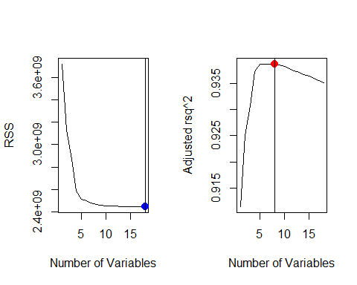

Plotting the the (Cp) statistic and BIC and identify the minimum points for each statistic using the which.min() function.
par(mfrow = c(1,2))
plot(model.summary$cp, xlab = "Number of variables", ylab = "Cp", type = "l")
Cp.min <- which.min(model.summary$cp)
points(Cp.min, model.summary$cp[Cp.min], col = "red", cex = 2, pch = 20)
plot(model.summary$bic, xlab = "Number of variables", ylab = "BIC", type = "l")
BIC.min <- which.min(model.summary$bic)
points(BIC.min, model.summary$bic[BIC.min], col = "blue", cex = 2, pch = 20)
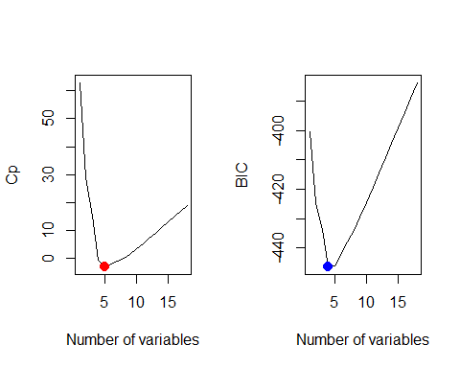
data.frame(
Cp = model.summary$cp,
adjr2 = model.summary$adjr2,
BIC = model.summary$bic,
RSS = model.summary$rss)
## Cp adjr2 BIC RSS
## 1 62.86654283 0.9114232 -400.3859 3716877719
## 2 28.76032557 0.9250095 -424.4108 3127925990
## 3 15.07566896 0.9307259 -433.7021 2872083469
## 4 -0.50918828 0.9372641 -446.3539 2585245554
## 5 -2.97380067 0.9386573 -446.0530 2512420390
## 6 -1.93849317 0.9386652 -441.9849 2496684670
## 7 -0.93617515 0.9386866 -437.9602 2480410838
## 8 0.07568215 0.9387043 -433.9321 2464292607
## 9 1.62100487 0.9385044 -429.3115 2456876073
## 10 3.39076617 0.9382098 -424.4402 2453120502
## 11 5.27788262 0.9378629 -419.4372 2451279186
## 12 7.24472537 0.9374784 -414.3446 2450738337
## 13 9.14456614 0.9371170 -409.3274 2449104575
## 14 11.02531025 0.9367589 -404.3318 2447159315
## 15 13.00612730 0.9363537 -399.2235 2446846410
## 16 15.00488437 0.9359355 -394.0950 2446826136
## 17 17.00090720 0.9355129 -388.9696 2446761262
## 18 19.00000000 0.9350834 -383.8407 2446746464
coef(model, RSS.min)
## (Intercept) ContinentAsia
## -7.444527e+02 -1.142552e+02
## ContinentAustralia/Oceania ContinentEurope
## -4.597162e+02 -1.557199e+02
## ContinentNorth America ContinentSouth America
## 7.222877e+02 -9.330828e+02
## Population TotalCases
## -1.353617e-05 3.932303e-02
## TotalRecovered Tot.Cases.1M.pop
## -5.419699e-03 -2.870301e-01
## Deaths.1M.pop TotalTests
## 1.490370e+01 -3.246618e-04
## Tests.1M.pop WHO.RegionAfrica
## 7.873085e-05 7.896237e+02
## WHO.RegionAmericas WHO.RegionEasternMediterranean
## 1.336675e+03 2.034886e+03
## WHO.RegionEurope WHO.RegionSouth-EastAsia
## 1.110214e+03 1.084668e+03
## WHO.RegionWesternPacific
## 1.651329e+03
coef(model, adjr2.max)
## (Intercept) ContinentSouth America
## 1.402868e+02 -1.814010e+03
## Population TotalCases
## -1.439348e-05 3.591095e-02
## Tot.Cases.1M.pop Deaths.1M.pop
## -2.923412e-01 1.477488e+01
## TotalTests WHO.RegionAmericas
## -2.858672e-04 1.255810e+03
## WHO.RegionEasternMediterranean
## 1.021806e+03
coef(model, Cp.min)
## (Intercept) Population TotalCases Tot.Cases.1M.pop
## 3.581635e+02 -1.469252e-05 3.588369e-02 -2.875918e-01
## Deaths.1M.pop TotalTests
## 1.436565e+01 -2.705773e-04
coef(model, BIC.min)
## (Intercept) Population TotalCases Tot.Cases.1M.pop
## 2.464588e+02 -1.474161e-05 3.291027e-02 -2.797276e-01
## Deaths.1M.pop
## 1.458956e+01

